Student Self-Evaluation for presentation:

Student ID:

|  |  |  |
| --- | --- | --- |
| **Criteria: explanation** | **Allocation** | **Grade** |
| **PowerPoint: The quality and content of the PowerPoint presentation.**   * Presentation Structure * Presentation use of bullet points * Use (but not overuse) of animation * Good use of images and graphics * Color theme matches | 10pts |  |
| **Preparation: Did the group present in a professional manner?**   * Eye contact with the audience * Variable voice while speaking * Rehearsed (not reading from the slides). * Transitioning between groups. * Explanation of difficult terms. * Dressed for the occasion. * The presentation content is presented in an interesting way. | 10pts |  |

**Explain your evaluation of your presentation:**

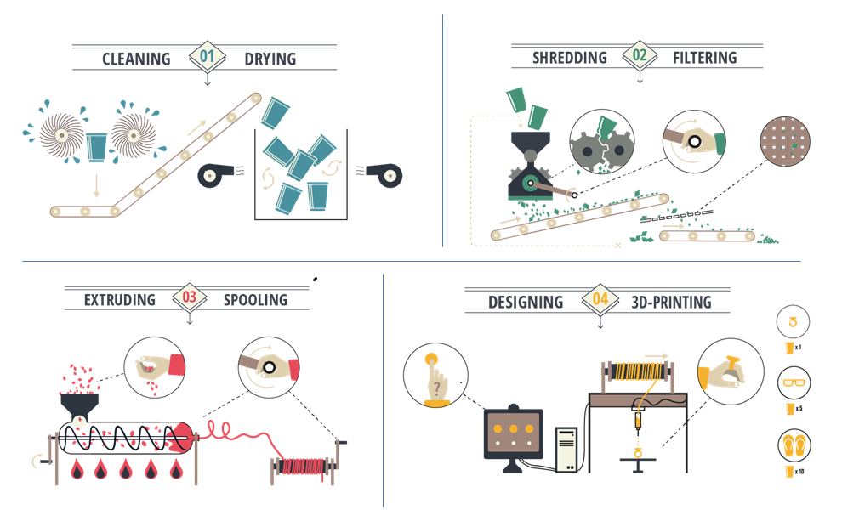  
**This is the image used for the report group work**

**Explain what you will do to improve key challenges you had in the presentation:**